Internal Quarterly Report

Date of Report: 4th Quarterly Report – October 7, 2025
Contract Number: 693JK32410014POTA
Prepared for: DOT / PHMSA
Project Title: Use of Gamification and Generative AI to provide more effective training for hazardous condition and emergency response.
Prepared by: EnerSys Corporation
Contact Information: Russel W. Treat
E: rtreat@enersyscorp.com
O: 281-598-7110
M: 281-804-6171
For quarterly period ending: September 30, 2025

1: Items Completed During this Quarterly Period:
Item # | Task # | Activity/Deliverable | Title | Federal Cost | Cost Share
7 | 4 | Define generative AI training criteria for Team Training and Exercise Scenarios. | Specification of Training Scenarios, Training Outcomes and Multi-Player Requirements. | 3,776.00 | 6,840.00
8 | 5 | Define Materials for use in Training generative AI model | Specification of Training Scenarios, Training Outcomes and Multi-Player Requirements. | 3,224.00 | 8,280.00
9 | 6 | Define scenario training outcomes for use in training the generative AI model | Specification of Training Scenarios, Training Outcomes and Multi-Player Requirements. | 11,256.00 | 9,120.00
12 | 8 | Specify and create generative AI model training data | Develop Generative AI Model and Multi-Player training scenarios. | 9,732.00 | 5,700.00
14 | 8 | Train generative AI model to support exercise scenarios. | Develop Generative AI Model and Multi-Player training scenarios. | 1,888.00 | 0.00
17 | 8 | Define and develop specific scenarios | Develop Generative AI Model and Multi-Player training scenarios. | 6,488.00 | 10,000.00
24 | 13 | Submit 4th Quarterly Report | Submit 4th Quarterly Report | 5,952.00 | 1,140.00

2: Items Not-Completed During this Quarterly Period:

Item # | Task # | Activity/Deliverable | Title | Federal Cost | Cost Share
16 | 8 | Enhance ThreatGen AutoTableTop framework to incorporate features necessary for running trail scenarios. | Develop Generative AI Model and Multi-Player training scenarios. | 44,640.00 | 0.00
18 | 8 | Test and refine application | Develop Generative AI Model and Multi-Player training scenarios. | 9,088.00 | 40,000.00
20 | 9 | Prepare materials and organize field trails for running proforma exercises | Perform Field Tests | 9,488.00 | 6,840.00
21 | 9 | Run Field Trails | Perform Field Tests | 9,744.00 | 48,000.00
22 | 9 | Collect, Compile and Document Feedback | Perform Field Tests | 8,248.00 | 0.00
23 | 9 | Draft final report | Prepare & Submit Final Report | 11,452.00 | 16,420.00

3: Project Financial Tracking During this Quarterly Period:

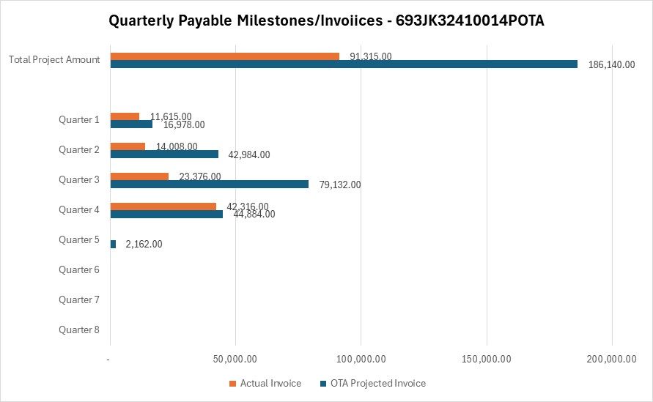

4: Project Technical Status

Item # | Task # | Activity/Deliverable | Title
7 | 4 | Define generative AI training criteria for Team Training and Exercise Scenarios. | Specification of Training Scenarios, Training Outcomes and Multi-Player Requirements.
The team created scenario template document (IR_TTX_Scenario_Template.docx). This template was used for formatting training material for processing by the generative AI model.
8 | 5 | Define Materials for use in Training generative AI model | Specification of Training Scenarios, Training Outcomes and Multi-Player Requirements.
The team determined that the best documents for base training of the generative AI was all NTSB pipeline incident reports since 1998 should be used to create a library of scenarios, a total of 49 reports. The team focused on 3 key event for initial tuning of the model: 1) Bellingham, WA 1999, 2) San Bruno, CA 2010, and 3) Marshall, MI 2010.
9 | 6 | Define scenario training outcomes for use in training the generative AI model | Specification of Training Scenarios, Training Outcomes and Multi-Player Requirements.
The scenario template document includes a section for defining desired training outcomes. In addition, the ThreatGen AutoTableTop BETA includes a section for modifying scenario outcomes. Specific outcomes for the base scenarios is documented in the following documents:
1) Pipeline_Safety_Scenario_TTX_Bellingham, WA 1999.docx,
2) Pipeline_Safety_Scenario_TTX_Marshall, MI 2010.docx, and
3) Pipeline_Safety_Scenario_TTX_San Bruno, CA 2010.docx
12 | 8 | Specify and create generative AI model training data | Develop Generative AI Model and Multi-Player training scenarios.
Each of the above scenarios has been loaded into the ThreatGen AutoTableTop BETA for pipelines. The scenario data in the above MS Word documents has been converted to JSON and loaded to train the model. The following JSON files have been uploaded to the PHMSA project site.
1) Pipeline_Safety_Scenario_TTX_Bellingham, WA 1999.json,
2) Pipeline_Safety_Scenario_TTX_Marshall, MI 2010.json, and
3) Pipeline_Safety_Scenario_TTX_San Bruno, CA 2010.json
14 | 8 | Train generative AI model to support exercise scenarios. | Develop Generative AI Model and Multi-Player training scenarios.
The generative AI model has been trained with the initial training data. At present the development team is running these scenarios to refine the scenarios. The following shows a preloaded scenario and a scenario interaction.
17 | 8 | Define and develop specific scenarios | Develop Generative AI Model and Multi-Player training scenarios.
The three base scenarios have been loaded into the ThreatGen TableTop.
24 | 13 | Submit 4th Quarterly Report | Submit 4th Quarterly Report
The 4th Quarterly report was submitted to PHMSA on Oct 7, 2025.

5: Project Schedule

Item # | Task # | Activity/Deliverable | Title
16 | 8 | Enhance ThreatGen AutoTableTop framework to incorporate features necessary for running trail scenarios. | Develop Generative AI Model and Multi-Player training scenarios.
The ThreatGen AutoTableTop BETA is complete and the project team is cycling software changes and scenarios to refine user experience. We expect a version ready for initial field trials to be available in mid to late November.
18 | 8 | Test and refine application | Develop Generative AI Model and Multi-Player training scenarios.
Testing and refinement has started. The project team expects to begin field trials in December, and to run further trials through March 2026. Refinement will continue throughout this period.
20 | 9 | Prepare materials and organize field trails for running proforma exercises | Perform Field Tests
Initial drafts of training materials are created. Field trial training materials will be finalized once a AutoTableTop BETA is appropriately matured, expected by end of December 2025.
21 | 9 | Run Field Trails | Perform Field Tests
The team expects to run trial in two stages. Stage one will be trails with members of the TAP, expected to be complete prior to December 31, 2025. Feedback from these trails will be incorporated into the AutoTableTop demo prior to the second stage trials. Second Stage trials will be conducted with both members of the TAP and other pipeline operators that have expressed interest in the project. Second stage trials are targeted for completion prior to March 31, 2026.
22 | 9 | Collect, Compile and Document Feedback | Perform Field Tests
This activity will be conducted parallel to the Second Stage trials.
23 | 9 | Draft final report | Prepare & Submit Final Report
An initial draft of the final report has been prepared. Drafting of the final report will continue through the Second Stage trials as information is collected. The final report is targeted to be complete no later than March 31, 2026.

